- Issue: Central Locking and Interior Light does not work
Possible Cause: Blown fuse
Steps to rectify:
- Locate the fuse holder under the hood next to the battery.
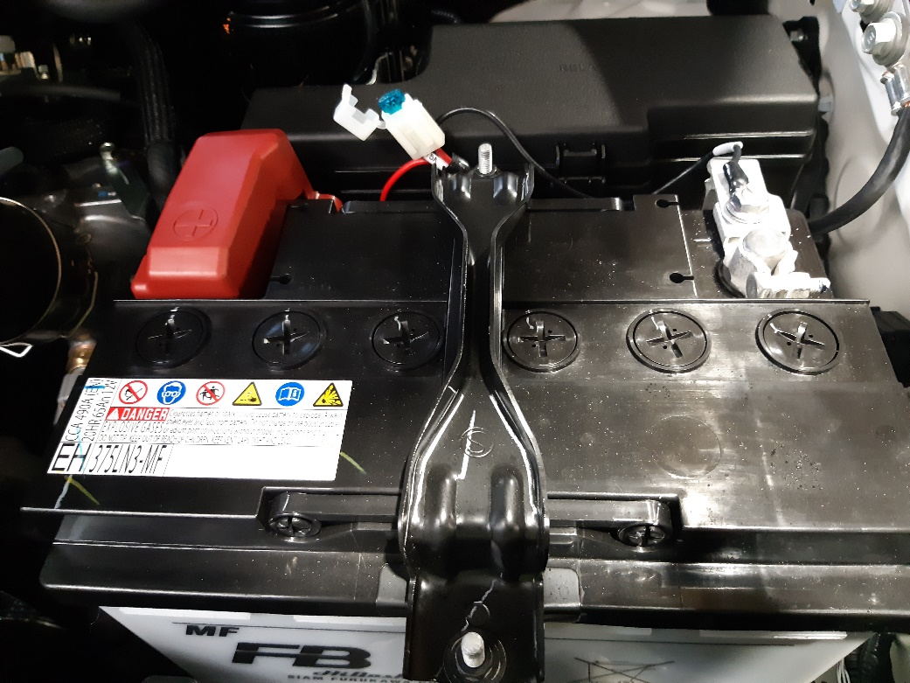
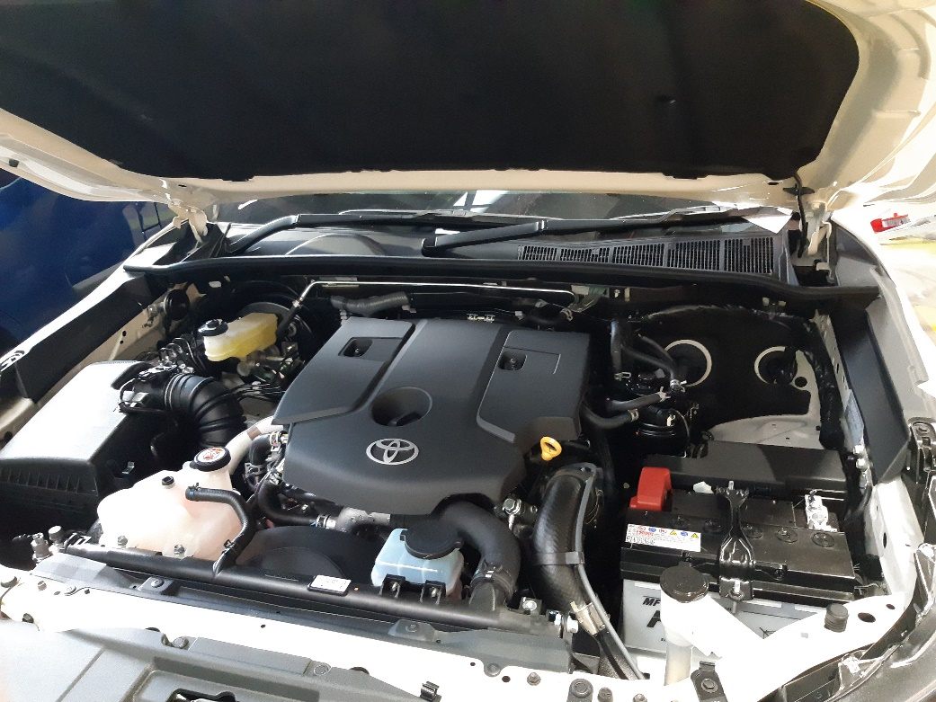

- Pull out the fuse. Check for gap or burnt mark on the fuse.

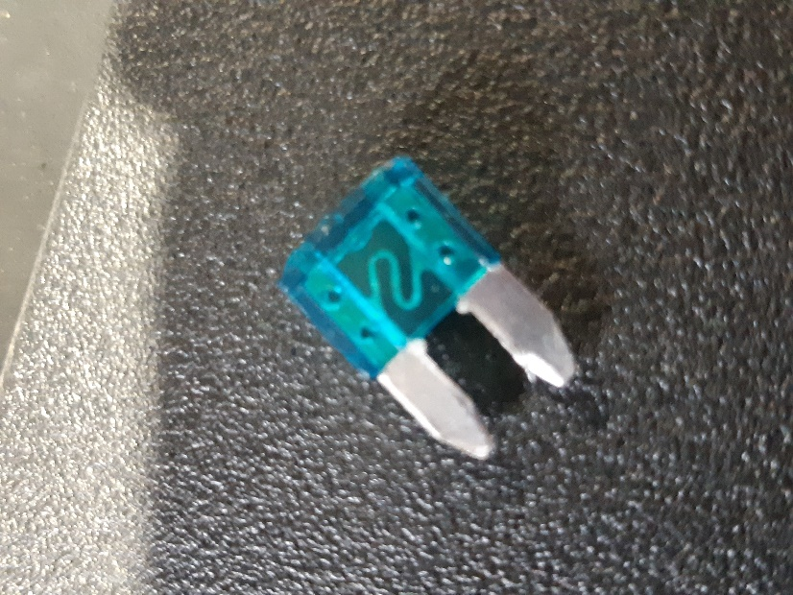
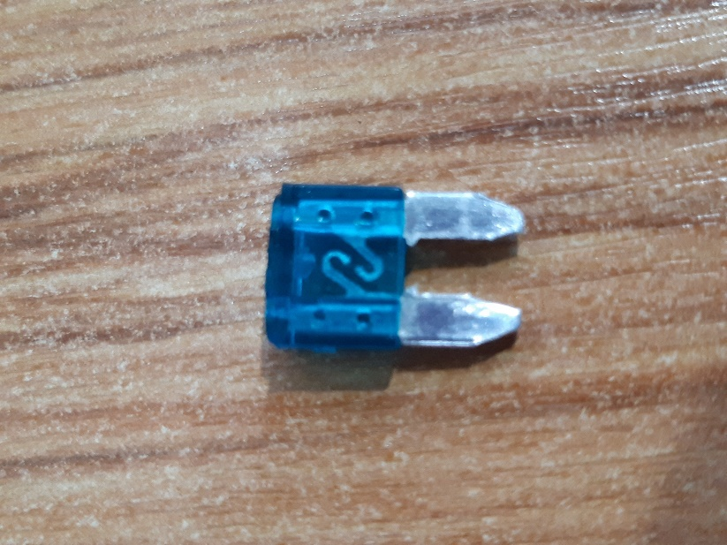
Normal Fuse
Burnt Fuse

- Swap the fuse. Use a 15amp fuse. Check if the interior light and the central locking is working.

- Issue: Central Locking on one of the windows does not work / Central Locking works intermittently.
Possible Cause: Faulty actuator
Steps to rectify:
- Identify which windows that has a faulty central locking.
- Take off the interior cover.
- Perform continuity test on the actuator by using test light. If there is continuity, but the actuator is seized or only worked intermittently, swap the actuator.
- Check if the central locking is working.

- Issue: Central Locking does not work + interior light & actuator does /does not work.
Possible Cause: Faulty module

Steps to rectify:
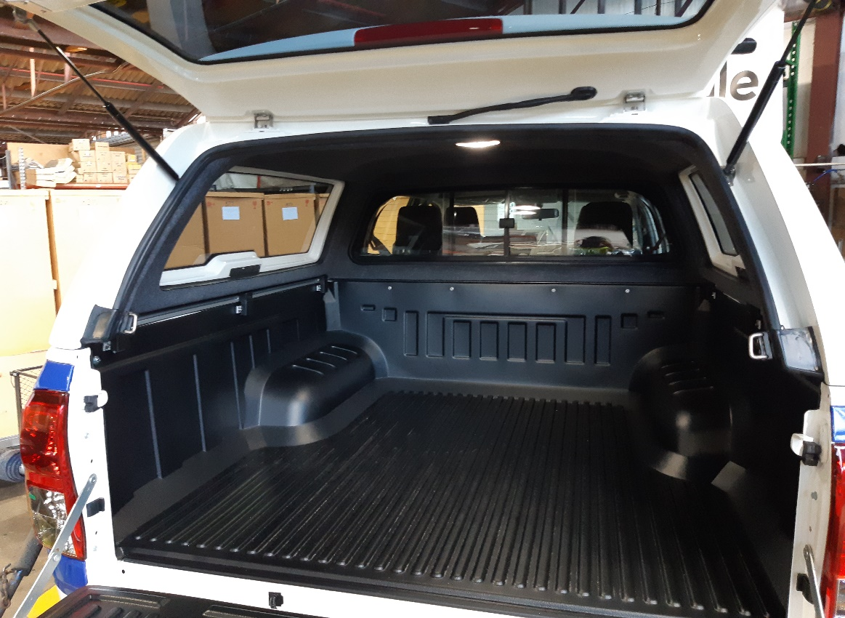
- Locate the central locking module. The module is commonly at the rear left-hand side of the canopy. On some models, the module is glued to the canopy shell on top of the interior light. (you will have to take off the interior light.)
Central locking module is located either on the rear LHS of the canopy OR glued to canopy shell under the carpet lining.

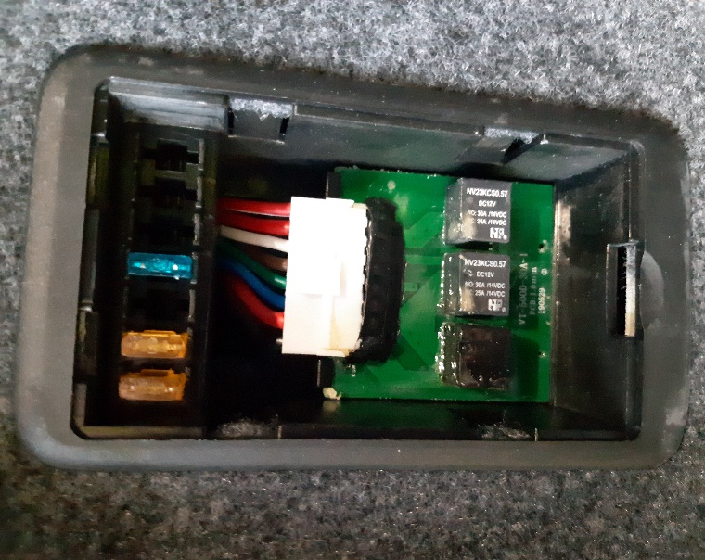
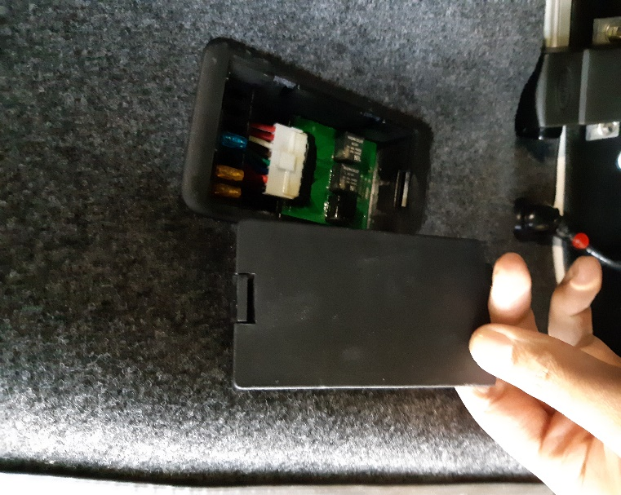
- Check for any gap or burnt mark on the fuse. You can also test the fuse by using a test light.

- Swap any burnt fuse with a new one.
- If the central locking still does not work, unplug the module and swap with a new one.
- Check if the central locking is now working.

- Issue: Canopy Central Locking works oppositely with the vehicle.
Possible Cause: Central Locking has been wired incorrectly.
Steps to rectify:
- Unplug the rubber housing at the rear left hand-side of the canopy.
- Identify the central locking wire. (brown and white wire)
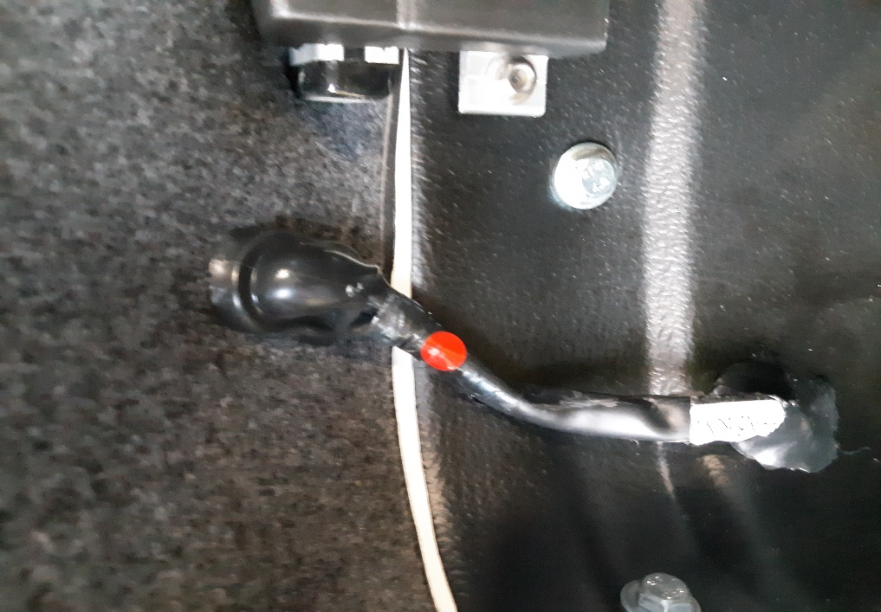
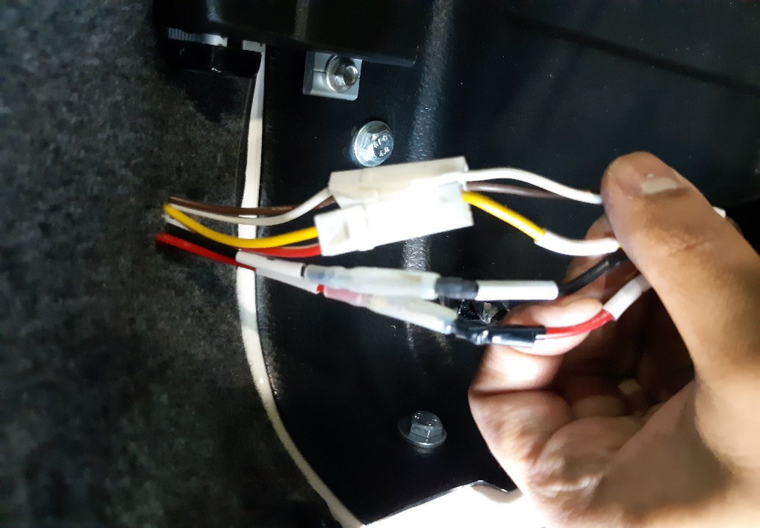

- Cut and strip both of the wire. Cross joint the wire as per following arrangement (white to brown, brown to white).
- Check if the central locking is working correctly. Solder the wire.
- Tips: Makes sure that the fuse has be taken out before soldering the wire.
- Secure all wiring back to its place.
Tips: It is always a good practice to perform a continuity test on the canopy wiring loom. Start from the wiring connection on the rear left-hand side of the canopy – central locking module – actuator inside the windows.

