SWAPING ACTUATOR
- Identify the type of canopy to determine which actuator needed.
Canopy Model |  | Side door | Rear door
CMX |  | KY-RMT-01-2S-2-CMX | KY-RMT-01-2R
CME |  | KY-RMT-01-2S-2-CMX | KY-RMT-01-2R
GSX |  | KY-RMT-01-2S | KY-RMT-01-2R
GSE | GSE-S | NA | KY-RMT-01-2R
 | GSE-L | KY-RMT-01-2S-2-CMX | KY-RMT-01-2R
GSS |  | NA | KY-RMT-01-2R
Table 1 Actuator Parts for different model of Canopy
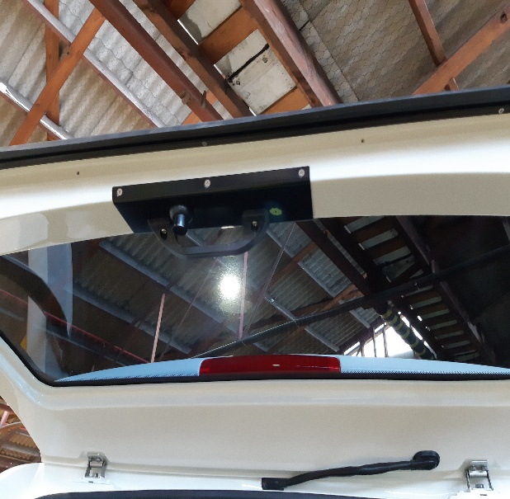
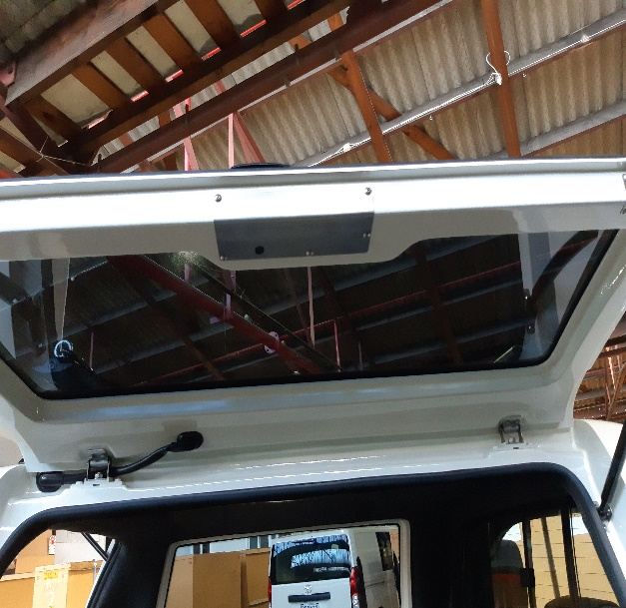
- Actuator is located inside of the canopy door. Remove the interior plate cover to locate the actuator.
Figure 2 Rear door interior handle
Figure 2 Sides Interior Plate

- Remove the linkage that hold the latching rod of the canopy window catch. (Tips: Unscrew the side catch of the canopy door).
- Unscrew the middle screw that hold the barrel of the handle. If possible, do not remove completely.
- Remove the screws that hold the linkage and plate to the actuator.
- Slide the actuator slightly to the side and take it out.
- Swap the actuator and reverse the process.
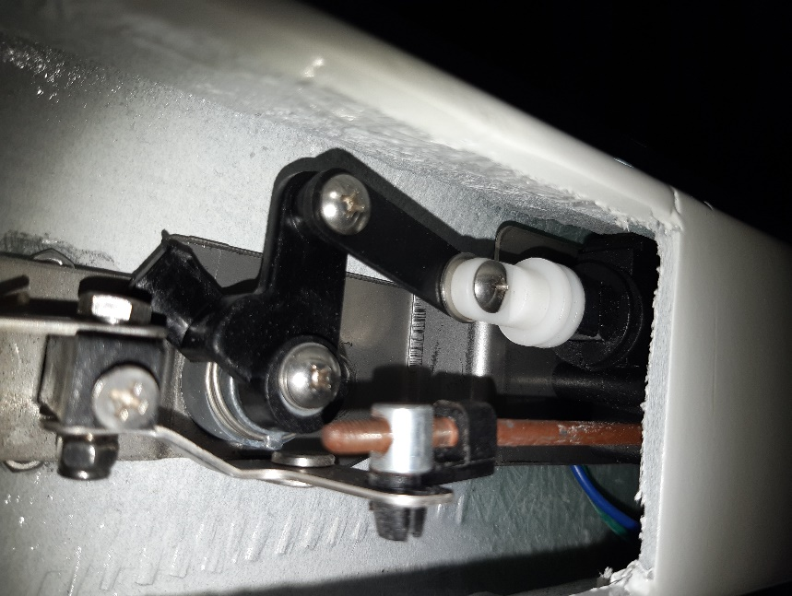
Special instruction: Some canopy might have the older cylinder shape actuator which is commonly used on the rear door of the GSE canopy.
Figure 4 Old Actuator (Obsolete)
Figure 3 Locking mechanism inside canopy door
4. Remove the linkage to actuator screw
3. Unscrew to release actuator mounting bracket
2. Remove latching rod
5. Take out the actuator
1. Remove plastic link
This type of actuator has become obsolete. If the actuator has failed, swap it with the newer version along with the mounting bracket as per the following arrangement.
Canopy | Arrangement
CMX, GSE, GSX – Rear door | 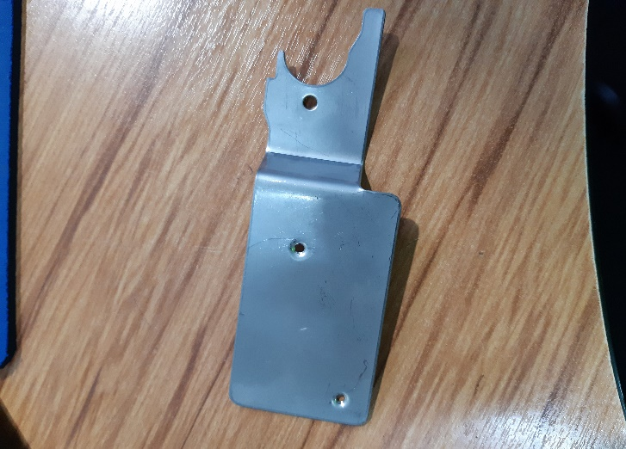  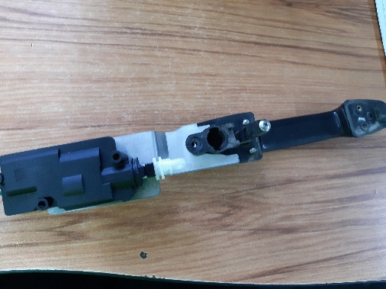  Figure 6 Actuator Mounting Bracket  Figure 6 Actuator arrangement
CMX, GSE,GSX – Side door | - No specific mounting bracket yet.  - Fitter need to make a custom bracket to fit the actuator to the canopy.

